TITLE

Avinash Shankar P T
Cyber Security Intern

- Advanced Log Analysis Report

Objective
To perform advanced log analysis using Elastic Security, including log correlation, anomaly detection, and log enrichment to identify suspicious activities in a SOC environment.

Tools Used
- Elastic Security (Kibana + Elasticsearch)
- Security Onion (conceptual reference)
- Google Sheets (for documentation)

1. Log Correlation
Task
Correlate failed login events (Event ID 4625) with outbound network activity.

Data Observed (From Your Logs)
From your dataset:
- Event Code: 4625 (Failed Login)
- Source IP: 192.168.1.100
- Destination IP: 8.8.8.8
- Event Action: Failed login
- Followed by: Network activity

Correlated Output Table

Timestamp | Event ID | Source IP | Destination IP | Notes
2025-08-18 17:30:00 | 4625 | 192.168.1.100 | 8.8.8.8 | Suspicious DNS request

Analysis
- Multiple failed login attempts were observed
- Followed by outbound traffic
- Indicates possible:
  - Brute force attempt
  - Data exfiltration attempt

Proof
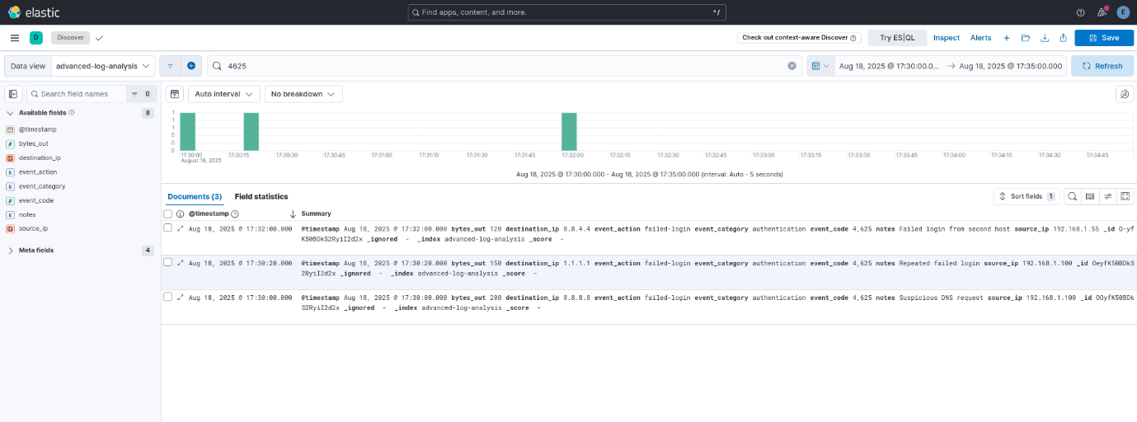

2. Anomaly Detection
Task
Detect high-volume data transfers (bytes_out > 1MB)

Rule Configuration
- Rule Type: Custom Query
- Query:
bytes_out > 100000
- Schedule:
  - Runs every: 1 minute
  - Look-back: Extended (for historical logs)

Result
- 6 alerts generated
- Severity: High
- Rule Name:
  - High outbound data transfer in 1 minute

Analysis
- High outbound traffic detected
- Indicates possible:
  - Data exfiltration
  - Suspicious outbound communication

🖼️ Proof
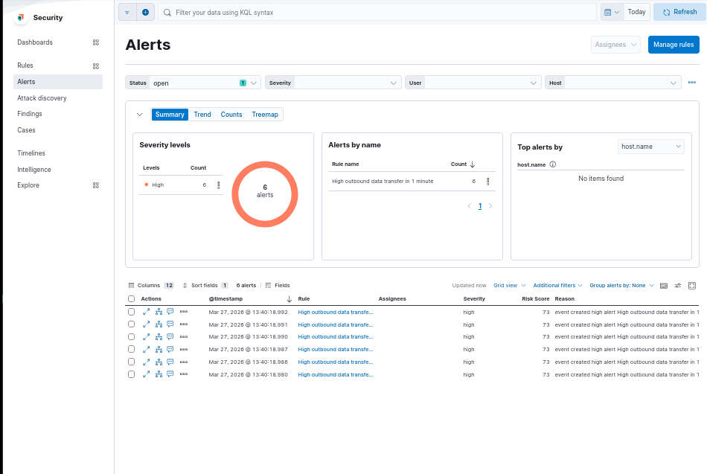

3. Log Enrichment (GeoIP)
Task
Add geolocation data to IP addresses

Pipeline Configuration
- Processor: GeoIP
- Field used: destination_ip
- Output field: destination.geo

Result
Destination IP | Country | Latitude | Longitude
8.8.8.8 | United States | 37.751 | -97.822
52.97.132.18 | Finland | 60.17 | 24.93

Analysis
- Outbound traffic mapped to real-world locations
- Helps identify:
  - Suspicious external connections
  - Data exfiltration destinations

Proof
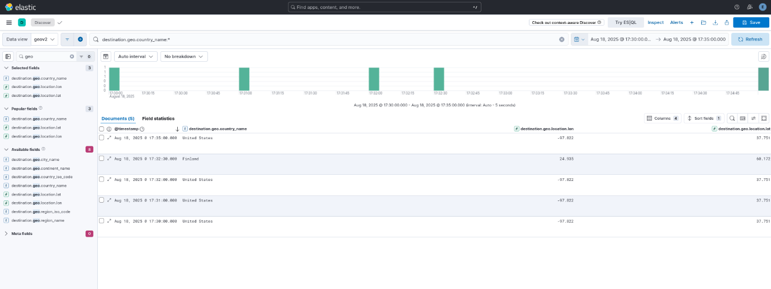

50-Word Summary
GeoIP enrichment added geographic context to destination IP addresses in the logs. Public IPs were enriched with country and location metadata, helping identify where outbound traffic was going. This improved visibility for investigation, made suspicious connections easier to analyze, and supported faster triage during security monitoring and incident response.

Overall Findings
- Failed login attempts were detected (Event ID 4625)
- Correlated with outbound traffic → potential attack pattern
- High-volume data transfer alerts confirmed anomalies
- GeoIP enrichment provided geographic visibility

Conclusion
The analysis successfully demonstrated:
- Log correlation to identify suspicious behavior
- Anomaly detection using rule-based monitoring
- Log enrichment to enhance investigation

This workflow simulates real-world SOC operations for detecting threats and responding effectively.

- Threat Intelligence Integration Report

Objective
The objective of this task is to integrate external threat intelligence into Wazuh using AlienVault OTX data, enrich alerts with IP reputation, and improve threat detection and analysis.

Tools Used
- Wazuh SIEM – Log analysis and alerting
- AlienVault OTX – Threat intelligence feed (IOC data)
- TheHive – Case management (optional for escalation)

Methodology
The AlienVault reputation IP list was downloaded and integrated into Wazuh as a threat intelligence source. The list was converted into a Wazuh-compatible format (CDB list) and loaded into the Wazuh ruleset.
A custom detection rule was created to compare incoming log events (srcip) against the imported threat intelligence list.

Testing
A mock malicious IP address was used:
192.168.1.100
A test event was generated in Wazuh logs using a JSON input file:
{"srcip":"192.168.1.100","event":"login_failed","user":"admin"}

Alert Enrichment
Observed Alert (From Wazuh Dashboard)
The system successfully detected and enriched the alert using threat intelligence data.

Alert Details

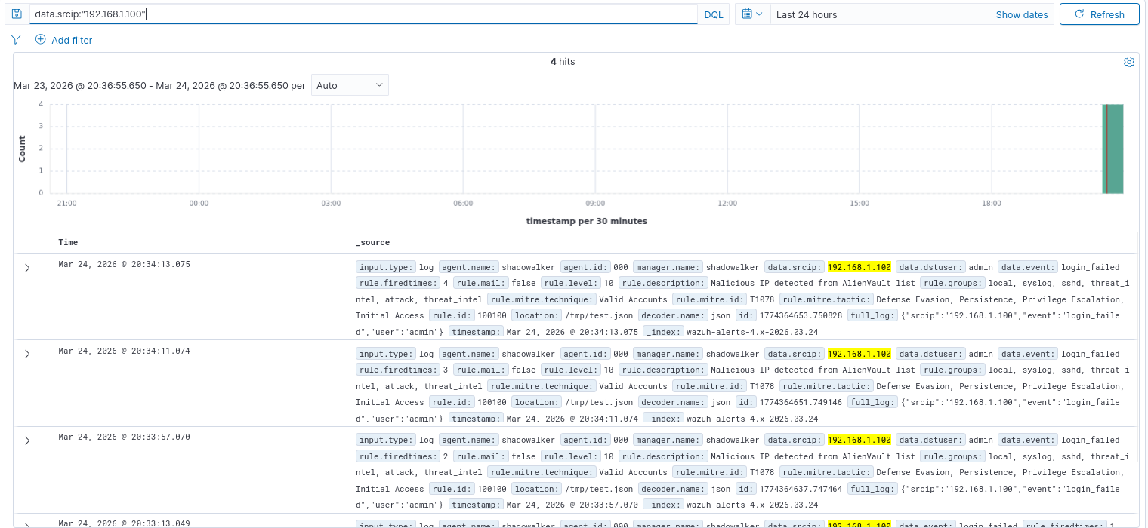

Analysis
The Wazuh SIEM matched the incoming log event with the AlienVault threat intelligence list. The IP address 192.168.1.100 was identified as malicious and flagged accordingly. The alert was enriched with contextual information, including MITRE ATT&CK mapping (T1078 – Valid Accounts), enabling faster and more accurate incident triage.

Results
- Successfully integrated AlienVault threat intelligence into Wazuh
- Generated alert based on IOC match
- Enriched alert with reputation data
- Verified alert in Wazuh Dashboard
- Improved visibility into malicious activity

Conclusion
The integration of AlienVault OTX threat intelligence into Wazuh enhances the SOC’s ability to detect known malicious indicators. By enriching alerts with reputation data, analysts can prioritize threats more effectively and reduce false positives. This approach strengthens overall security monitoring and incident response capabilities.

Short Summary
Threat intelligence integration was successfully implemented by importing AlienVault OTX data into Wazuh. A custom rule enabled detection of malicious IPs, and alerts were enriched with reputation information. This improved threat visibility and allowed efficient identification and analysis of suspicious activities.

Threat Hunting Report – MITRE ATT&CK T1078

Objective
The objective of this task is to perform threat hunting in Wazuh logs to identify suspicious usage of valid user accounts, mapped to MITRE ATT&CK technique T1078 (Valid Accounts).

Tools Used
- Wazuh SIEM (Dashboard & Discover)
- Wazuh Manager (Log collection & analysis)

Methodology
Step 1: Access Wazuh Dashboard
The Wazuh Dashboard was accessed through the web interface, and the Discover module was opened to analyze security events.

Step 2: Select Index
The index pattern selected was: wazuh-alerts-*
This index contains all security alerts generated by Wazuh.
Step 3: Set Time Range
The time range was configured to: Last 24 hours to capture recent authentication activities.

Step 4: Apply Threat Hunting Query
The following query was used to identify events related to MITRE T1078:
rule.mitre.id:"T1078"
This filters logs associated with valid account usage.

Step 5: Analyze Results
The query returned multiple events indicating valid account activity. Key observations include:
- PAM Login Events
  - Description: Login session opened
  - User: shadowalker
  - Target: root
  - MITRE ID: T1078
- Privilege Escalation
  - Multiple sudo executions to root account
  - Indicates elevated access using valid credentials
- Threat Intelligence Correlation
  - IP address 192.168.1.100 detected as malicious
  - Linked with login attempts

Time | User | Target | Event | MITRE | Notes
20:34:13 | shadowalker | root | Login session opened | T1078 | Valid account usage
20:34:13 | admin | system | Malicious IP login | T1078 | IOC detected
20:34:11 | shadowalker | root | sudo access | T1548 | Privilege escalation

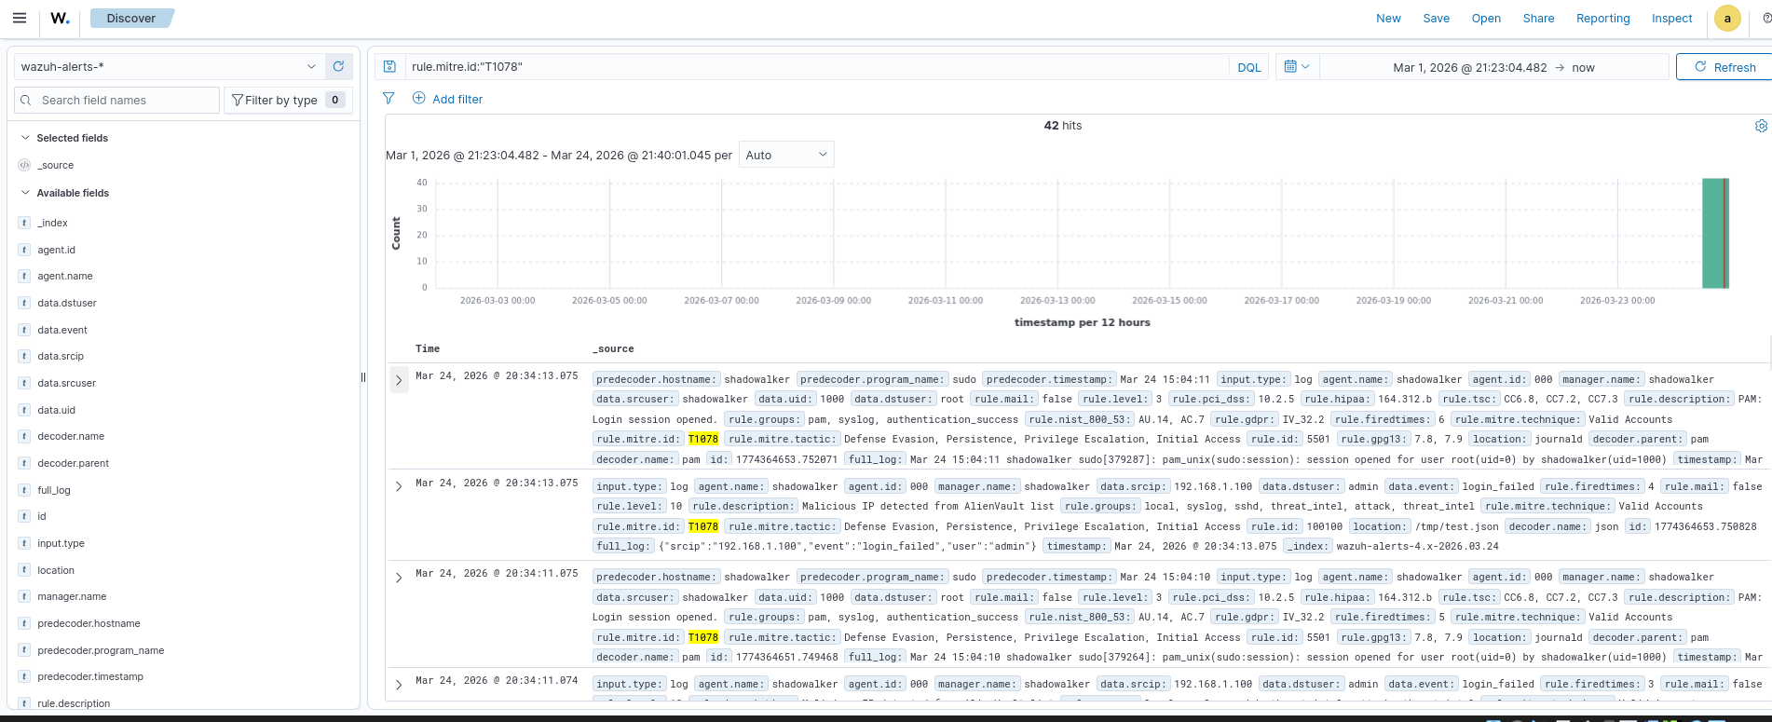

Analysis
The analysis revealed repeated authentication events using valid user credentials. The presence of multiple login sessions and privilege escalation activities suggests potential misuse of legitimate accounts. Additionally, the involvement of a malicious IP address increases the likelihood of credential compromise or unauthorized access.

Conclusion
Threat hunting using Wazuh successfully identified suspicious activities related to MITRE ATT&CK technique T1078. The findings indicate possible credential misuse, including repeated logins and privilege escalation. Continuous monitoring, enforcing strong authentication mechanisms, and reviewing user activity are recommended to mitigate such threats.

Summary
Threat hunting using the query rule.mitre.id:"T1078" revealed multiple authentication events involving valid user accounts. Logs showed repeated login sessions and privilege escalation to root using sudo. A malicious IP was also detected during login attempts. These activities indicate potential credential misuse and require monitoring and stronger access controls.

- Incident Escalation Practice Report

Objective
The objective of this task is to simulate a real-world SOC incident escalation process using TheHive, document the incident through a Situation Report (SITREP), and design a workflow automation using Splunk Phantom to improve response efficiency.

Tools Used
- TheHive – Case management and incident response
- Google Docs – Documentation and reporting (SITREP)
- Splunk Phantom (SOAR) – Workflow automation (conceptual)

1. Escalation Simulation (TheHive)

Scenario
A high-priority alert was generated indicating unauthorized access on Server-Y from IP address 192.168.1.200 at 2025-08-18 13:00.
The activity was mapped to MITRE ATT&CK Technique T1078 (Valid Accounts).

Steps Performed
- Logged into TheHive dashboard
- Created a new case with the following details:
  - Title: Unauthorized Access on Server-Y
  - Severity: High
  - TLP: Amber
  - PAP: Amber
  - Tags: T1078, Unauthorized Access
- Added observable:
  - Type: IP Address
  - Value: 192.168.1.200
- Added incident description
- Set case status to In Progress
- Assigned case to simulate escalation to Tier 2 analyst

Escalation Summary
A high-priority incident was identified involving unauthorized access to Server-Y from IP address 192.168.1.200. Initial triage revealed suspicious authentication activity mapped to MITRE ATT&CK technique T1078, indicating possible misuse of valid credentials. The affected system was isolated to prevent further compromise. A case was created in TheHive and escalated to Tier 2 for deeper investigation. Immediate actions included reviewing logs, monitoring user activity, and enforcing password resets. The incident remains under investigation, and enhanced monitoring has been implemented to detect further suspicious activity.

2. SITREP (Situation Report)

Title
Unauthorized Access on Server-Y

Summary
Unauthorized access was detected on Server-Y at 2025-08-18 13:00 from IP address 192.168.1.200.
The activity was mapped to MITRE ATT&CK Technique T1078 (Valid Accounts), indicating possible misuse of legitimate credentials.

Actions Taken
- Server-Y isolated from network
- Incident escalated to Tier 2
- Logs collected and analyzed
- User credentials reviewed and reset
- Continuous monitoring enabled

Status
Investigation is ongoing. No confirmed evidence of data exfiltration at this stage.

3. Workflow Automation (Splunk Phantom)

Objective
To automate the escalation of high-priority alerts to Tier 2 analysts, reducing manual effort and improving response time.

Playbook Design
Playbook Name
High Priority Alert Escalation

Trigger
- New alert generated from SIEM (Wazuh)

Condition
IF alert.severity == "High"

Actions
- Assign alert to Tier 2 analyst
- Add note: “Automatically escalated due to high severity”
- Send notification to SOC team
- Update alert status to “In Progress”

Test Simulation
Mock Alert Input
{
"alert_id": "A-1001",
"severity": "High",
"description": "Unauthorized access detected",
"ip": "192.168.1.200"
}

🔹 Expected Output
- Alert automatically assigned to Tier 2 analyst
- Escalation note added
- Notification sent to SOC team
- Status updated to “In Progress”

Results
The simulated playbook successfully demonstrated automated handling of high-priority alerts. The system correctly identified alert severity and performed escalation actions without manual intervention, improving efficiency and consistency.

Conclusion
The incident escalation process was successfully implemented using TheHive for case management and Google Docs for reporting. A high-priority alert was analyzed, escalated, and documented effectively. Additionally, workflow automation using Splunk Phantom demonstrated how SOC operations can be optimized through automated alert handling, reducing response time and human effort.

- Alert Triage with Threat Intelligence Report

Objective
The objective of this task is to perform alert triage using Wazuh and validate Indicators of Compromise (IOCs) using external threat intelligence sources such as VirusTotal and AlienVault OTX.

Tools Used
- Wazuh SIEM
- VirusTotal
- AlienVault OTX

1. Triage Simulation (Wazuh)

Alert Evidence
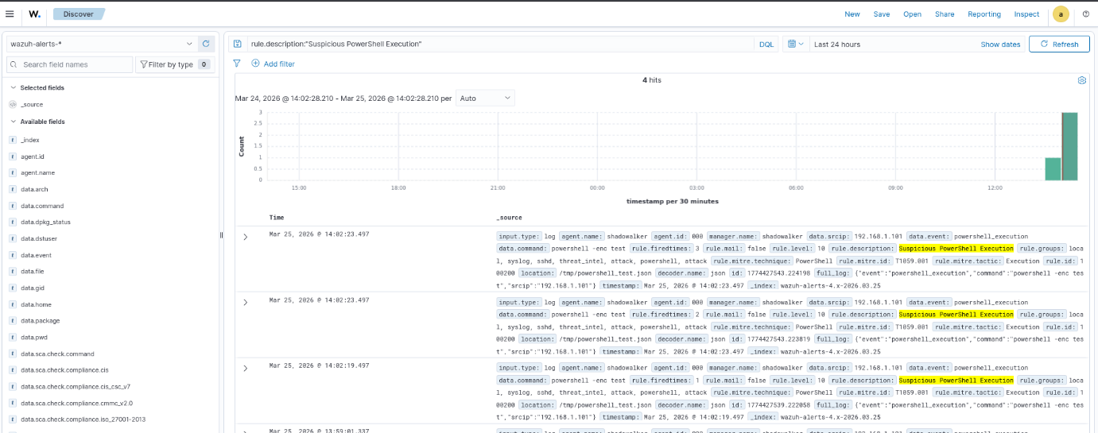
Alert Details

Alert ID | Description | Source IP | Priority | Status
004 | PowerShell Execution | 192.168.1.101 | High | Open

Analysis
The alert shows execution of a PowerShell command:
powershell -enc test

Key Findings:
- PowerShell is commonly abused by attackers
- Encoded command indicates obfuscation
- Multiple alert triggers observed
- Mapped to MITRE ATT&CK: T1059.001 (PowerShell Execution)
This behavior strongly suggests potential malicious activity such as command execution or payload delivery.

2. IOC Validation

🔎 VirusTotal Evidence

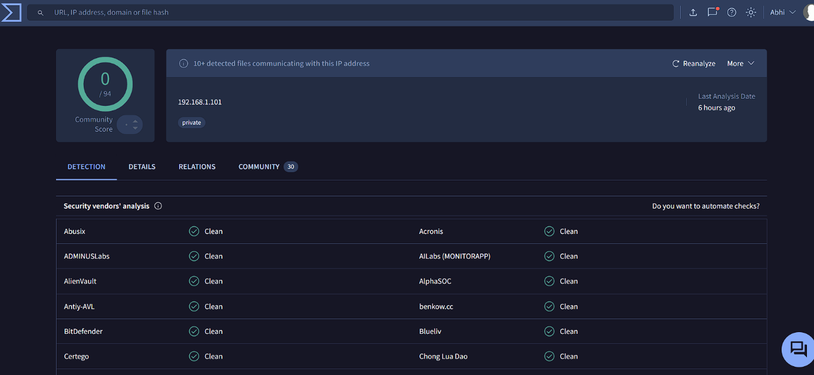

Result:
- IP: 192.168.1.101
- Detection: 0/94 (Clean)
- Classified as Private IP

AlienVault OTX Evidence

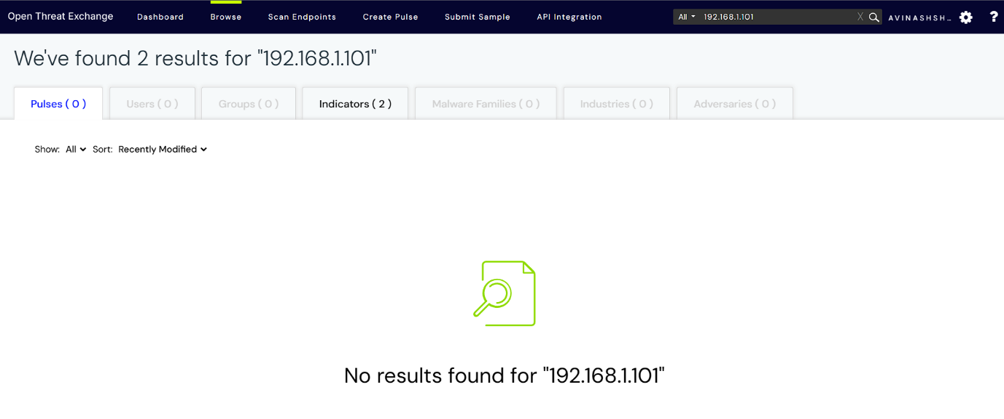

Result:
- No threat pulses found
- No malicious indicators linked

Interpretation
Although no malicious reputation was found:
- The IP is a private/internal address
- Public threat intelligence tools do not track internal IPs
- Detection is based on behavior (PowerShell abuse)
Therefore, the alert is still considered highly suspicious

3. IOC Validation Summary
The suspicious PowerShell execution alert was analyzed and linked to IP address 192.168.1.101. IOC validation using VirusTotal and AlienVault OTX showed no public malicious reputation, indicating the IP is likely internal. However, the behavior remains suspicious and suggests possible misuse of legitimate tools, requiring further investigation.

4. Conclusion
The alert triage process successfully identified suspicious PowerShell activity using Wazuh. Even though external threat intelligence sources did not flag the IP as malicious, behavioral indicators such as encoded PowerShell execution suggest potential malicious intent. This highlights the importance of combining behavioral detection with threat intelligence in SOC operations.

- Evidence Preservation and Analysis Report

Overview
This task focuses on collecting and preserving volatile and non-volatile evidence using Velociraptor and ensuring integrity through hashing. The objective is to maintain forensic soundness and proper chain-of-custody procedures.

- Volatile Data Collection (Network Connections)

Method Used
Velociraptor artifact: Windows.Network.Netstat
Query executed: SELECT * FROM netstat

Key Findings
PID | Process Name | Local IP | Port | Status | Notes
892 | svchost.exe | 0.0.0.0 | 135 | LISTEN | RPC service
4 | System | 192.168.29.39 | 139 | LISTEN | SMB service
404 | svchost.exe | 0.0.0.0 | 3389 | LISTEN | RDP enabled
2896 | elastic-agent.exe | 127.0.0.1 | 6789 | LISTEN | Local agent
648 | lsass.exe | 0.0.0.0 | 49664 | LISTEN | Authentication
492 | wininit.exe | 0.0.0.0 | 49665 | LISTEN | System process

Analysis
- Port 3389 (RDP) is open → possible remote access vector
- Port 139 (SMB) active → potential lateral movement risk
- Multiple svchost.exe processes listening → normal but must monitor
- No immediate suspicious external connections detected

2. Memory Acquisition
Method Used
Velociraptor artifact: Windows.Memory.Acquisition

Evidence Details
- File Name: PhysicalMemory.dd
- Size: ~4.6 GB
- Acquisition Tool: Velociraptor
- Source: Windows Server 2022 VM

- Integrity Verification (Hashing)

Command Used
sha256sum PhysicalMemory.dd

Hash Result
Algorithm | Hash Value
SHA256 | f591a0b13f3017bc1241ee7f9637a1288453463788ee8f2405def01c79bf3107

4. Chain of Custody
Item | Description | Collected By | Date | Hash Value
Memory Dump | Server-Y Dump | SOC Analyst | 2026-03-19 | f591a0b13f3017bc1241ee7f9637a1288453463788ee8f2405def01c79bf3107

5. Forensic Integrity Notes
- Evidence collected using trusted tool (Velociraptor)
- Hash generated immediately after acquisition
- No modification detected (hash ensures integrity)
- Data stored securely for further forensic analysis

6. Conclusion
The evidence collection process was successfully completed using Velociraptor. Network analysis revealed active services such as RDP and SMB, which may present security risks if misconfigured. A full memory dump was acquired and verified using SHA256 hashing to ensure forensic integrity. The collected evidence is ready for deeper analysis such as malware detection or memory forensics.

Incident Title: Samba Exploit on Metasploitable2

1. Executive Summary
A simulated cyber attack targeting a Samba service was detected from source IP 192.168.1.101 against a vulnerable system (192.168.1.102). The activity was identified by the Wazuh SIEM and classified as a high-severity alert due to exploit-like behavior mapped to MITRE ATT&CK T1210 (Exploitation of Remote Services).

The alert indicated a potential attempt to exploit a remote service vulnerability. Immediate response actions were initiated, including alert triage, threat validation, and containment. CrowdSec was used to generate a ban decision against the attacker IP, and firewall rules were enforced to block further communication.

The affected system was isolated to prevent lateral movement or additional compromise. The incident was escalated to Tier 2 using TheHive for further investigation. No significant impact was observed, and the response demonstrated effective SOC detection and containment capabilities.

2. Timeline
Time | Event Description
14:00 | Simulated Samba exploit event generated
14:01 | Wazuh alert triggered (Rule: Samba exploit detected)
14:02 | Alert triaged and analyzed
14:03 | CrowdSec ban decision created for 192.168.1.101
14:04 | Firewall rule applied and system isolated
14:05 | Incident escalated to Tier 2 via TheHive

3. Detection and Analysis
- Source IP: 192.168.1.101
- Target IP: 192.168.1.102
- Service: Samba
- Alert Severity: High (Level 10)
- MITRE ATT&CK: T1210 – Exploitation of Remote Services

Wazuh successfully detected the simulated exploit attempt using a custom rule that matched the samba_exploit event. Multiple alerts were observed, confirming repeated suspicious activity. The behavior indicated unauthorized exploitation attempts targeting exposed network services.

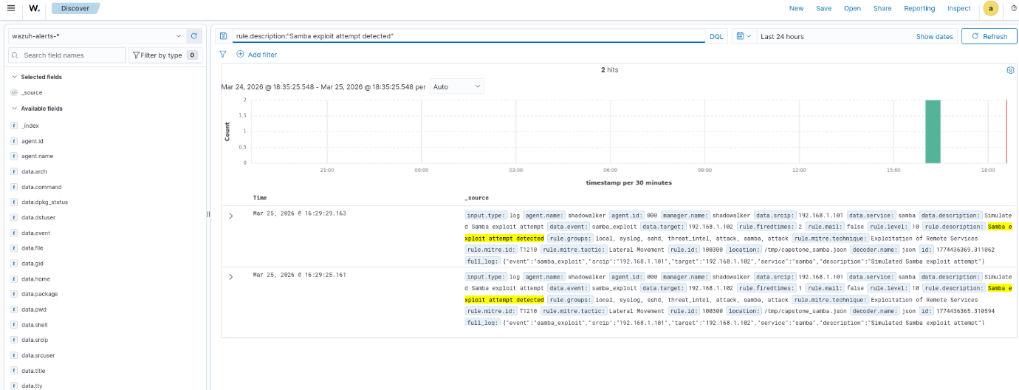

4. Response and Containment
The following containment actions were implemented:
- A CrowdSec ban decision was created for the attacker IP (192.168.1.101)
- Firewall rules (UFW/iptables) were applied to block incoming traffic from the attacker
- The affected system was isolated from the network

Verification
- CrowdSec decision verified using cscli decisions list
- Firewall rules confirmed active
- Ping test showed blocked or unreachable attacker IP
These actions successfully prevented further interaction from the attacker.
5. Escalation
The incident was escalated to Tier 2 using TheHive with the following details:

- Case Title: Samba Exploit on Metasploitable2
- Severity: High
- Tags: T1210, Samba Exploit
- Observable: 192.168.1.101
Case Summary
A high-severity incident was detected involving a simulated Samba exploit attempt from source IP 192.168.1.101 targeting a vulnerable system. Wazuh generated an alert mapped to MITRE ATT&CK T1210. Initial triage confirmed suspicious activity against the Samba service. CrowdSec created a ban decision, and firewall rules were used to enforce containment. The affected system was isolated, and the case was escalated to Tier 2 for further investigation and monitoring.

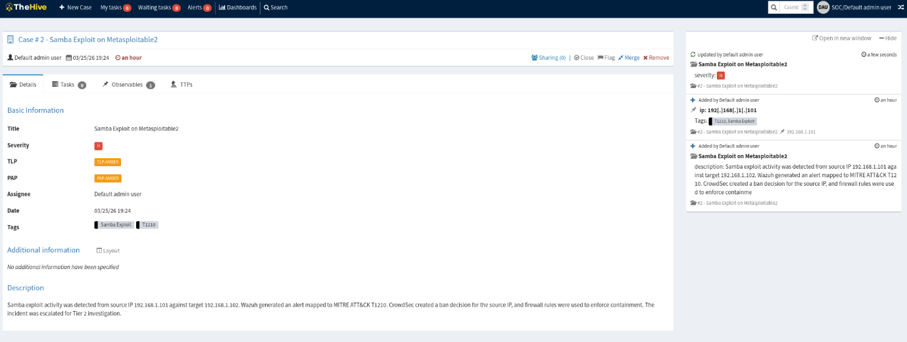

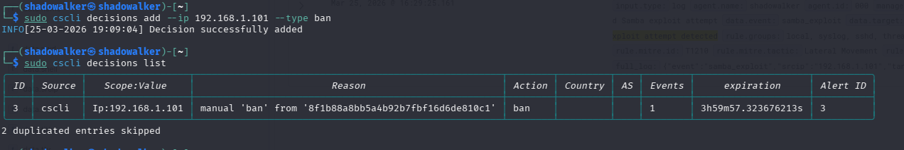

6. Recommendations
To prevent similar incidents in the future, the following actions are recommended:

- Patch and update Samba services to remove known vulnerabilities
- Restrict unnecessary network exposure and open ports
- Implement network segmentation to limit lateral movement
- Deploy automated containment tools such as CrowdSec firewall bouncers
- Continuously monitor logs using SIEM tools like Wazuh
- Conduct regular vulnerability assessments and penetration testing
- Improve incident response readiness through periodic SOC drills

7. Conclusion
This incident demonstrated a complete SOC workflow, including attack simulation, detection, triage, containment, and escalation. The tools used—Wazuh, CrowdSec, and TheHive—worked effectively together to detect and mitigate the threat. The exercise highlights the importance of proactive monitoring, rapid response, and structured incident management in modern cybersecurity operations.

Briefing for a non-technical manager, summarizing the incident and actions.

A simulated cyber incident was detected involving suspicious activity from an external IP address attempting to access a vulnerable system. Our security monitoring tools identified the behavior quickly, and the team responded by blocking the source of the activity and isolating the affected system to prevent any further risk. The situation was escalated for deeper investigation, and no damage or data loss occurred. This exercise demonstrated that our security controls and response processes are working effectively. Moving forward, we will strengthen system updates, improve network controls, and enhance automated response capabilities to further reduce the risk of similar incidents.

